**Effect of Mortality Rate on Country Population**

A mortality rate is defined by the number of deaths in a country that occur in known population size. The measure is always done at a specific time and generally, the period is the years as per the world bank statistics obtained. Death can be seen in various cases like a disease to other cases. The period when the mortality rate is determined is called the recall period. The mortality rate of a country has a significant effect on the total population of the country that varies over time (year). The equation for computing the mortality rate is as follows:

***Mortality rate = Total deaths in a specific period / (average population (in risk) x duration(year))***

Noe, to identify the effect of mortality rate on the population of countreis, the indicators have been selected from the collected dataset from the World Bank website. The data has been selected from 1960 to 2021 for 6 different countries namely Switzerland, Thailand, Turkey, United Kingdom, United States and Zimbabwe along with world data. Two data have been crated from the available one where one data contains countries on column and another contains years on the column. Now, statistical computation has been applied to calculate the average mortality and population by countries and the following outcomes have been achieved:

* Switzerland has the Average Mortality of 10.36 and an Average Population of 6888413.82
* Thailand has the Average Mortality of 51.43 and an Average Population of 53222680.43
* Turkey has the Average Mortality of 95.94 and an Average Population of 54071778.15
* The United Kingdom has the Average Mortality of 11.89 and an Average Population of 58467704.84
* The United States has the Average Mortality of 13.91 and an Average Population of 255028733.07
* Zimbabwe has the Average Mortality of 97.11 and an Average Population of 9491676.67
* The world has the Average Mortality of 18180850.85 and an Average Population of 5301718131.61

To visualize the statistics more clearly, the data have been combined in a data frame for the mortality and the total population has been calculated. The statistics are shown below:

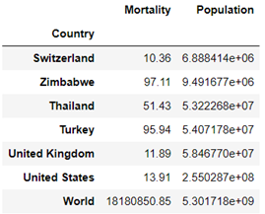

As the data has been created by storing all the statistical outcomes, those will be visualized below in the form of a bar charts. The bar chart helps to identify the discrete values of mortality and total population by country. It is also good for those who are not from the technical domain. This visualization helps them to identify the statistics as follows:

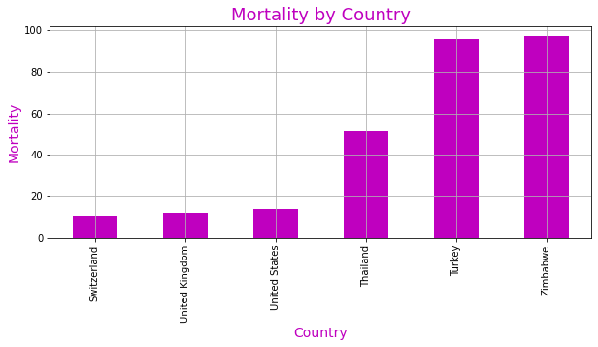 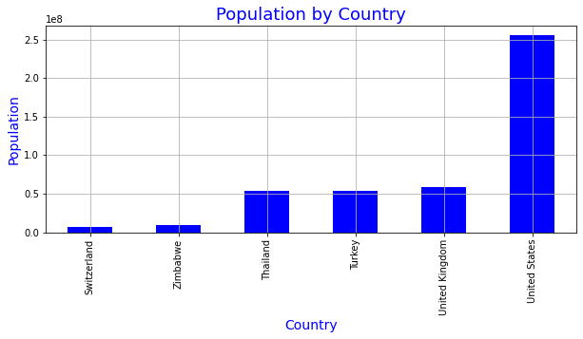

From the outcome of the statistics, it can be seen that the mortality rate is higher for Turkey and Zimbabwe. Now, to identify the relationship between mortality and population by country, the correlation has been applied. Correlation is an important measure that reflects the relationship between the mortality rate and population. If the value of correlation will be highly positive, it defines that a higher mortality rate will affect the population and vice versa. To visualize the correlation, a heatmap with the preferred colour has been chosen as it graphically shows the correlation value. as follows:

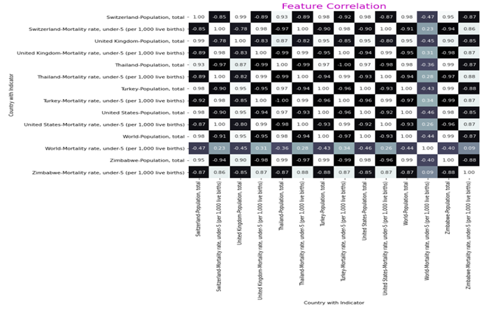

From the correlation, it can be seen that the mortality rate is negatively correlated. It means, that if the mortality rate will be increased in a country, the population will be higher. Additionally, the relationship varies by country as seen in the correlation chart. For the USA, the correlation value is -0.92, for Switzerland, it is -0.85, for the UK, it is -0.85 etc. So, the effect of the mortality rate is different for different countries but the statistic is the same that the increase in the mortality rate will reduce the total population.